**Final Project**

**David Kalimi**

**Introduction**

Divorce is a complex and growing social phenomenon that raises questions about marital stability, cultural norms, and the evolving structure of families. Our project investigates the key factors contributing to divorce in Israel, guided by previous research1 that highlights variables such as financial hardship, age at marriage, education level, religious background, and family size. We chose to focus on Israel not only because its divorce rate is relatively high and close to the OECD average2 -  a group of economically developed nations that serve as a benchmark for global social trends, but also because of its rich social, religious, and demographic diversity. Additionally, Israel is relevant to us personally as citizens, and we found it to have the most accessible and comprehensive data available for this type of analysis.

We selected 2019 as the reference year for our study, as it precedes major societal disruptions such as COVID-19 and regional conflicts, which are known to have significantly influenced divorce trends3. This allows us to study more stable, intrinsic patterns rather than reactions to extreme external events.

Our general research question is: **What are the dominant predictors of divorce in Israel?** To answer this, we explored cultural and demographic indicators such as voting behavior, ethnic composition, education, and employment levels, using both direct comparisons and clustering techniques. This study contributes to the broader understanding of family dynamics and social resilience by identifying patterns not only at the national level but also within specific types of communities. Understanding these patterns may help raise public awareness and guide future policy aimed at supporting family stability in diverse population groups.

This is also a challenging question to study. Marriage and divorce are deeply personal, often influenced by subjective and non-measurable factors, which makes generalization difficult. Prior studies often describe correlations but rarely go deeper into subgroup dynamics. Our approach is to use clustering and statistical modeling to segment the Israeli population and uncover whether specific groups—sometimes assumed to be stable—are indeed less prone to divorce. This forms the groundwork for further insights revealed later in our report.

**Data Overview**

Our dataset contains demographic, socioeconomic, and cultural information for localities in Israel, all from the year 2019. The data was sourced from the official Israeli government data portal (gov.il) and includes 64 features, which we organize into three main feature families:

**- General City Data:** Includes variables related to population size, age group distribution, population growth/decline, and ethnic composition (e.g., Jews, Arabs, Others)

- **Socioeconomic Indicators:** Captures employment status, education levels, and household-related economic conditions, such as unemployment rates, job placements, and the academic vs. non-academic population.

- **Cultural Proxies:** Represents cultural and religious identity through voting patterns in national elections. This includes both raw votes for individual parties (e.g., Shas, Meretz, Likud) and aggregated categories such as votes_haredi, votes_arab, and votes_other.

The **target** variable is divorces_sum, which reflects the number of divorces recorded in each city during 2019.

This structured categorization of features helps us explore meaningful correlations between demographic, economic, and cultural factors and divorce rates. By distinguishing these families, we aim to better identify patterns and understand the underlying drivers of divorce in Israeli society.

**Methods and Results**

The aim of this study was to explore the demographic and cultural factors that influence divorce rates across Israeli cities.

We began our investigation with a simple comparison between several well-known cities. Tel Aviv, Jerusalem, and Bnei Brak. We observed large differences in divorce rates, which appeared to align with each city’s social and cultural profile. For example, Tel Aviv, known for its secular and liberal character, showed relatively high divorce rates, while Bnei Brak, a predominantly ultra-Orthodox city, had extremely low rates.

To deepen the comparison, we added two more cities: Pardes Hanna-Karkur, another liberal and fast-growing community, and Nof HaGalil, a mixed city with both Jewish and Arab residents. While not a majority-Arab city, Nof HaGalil was selected as a proxy due to the lack of complete data on predominantly Arab municipalities in our dataset. Together, these five cities offered a meaningful snapshot of Israel’s social diversity and allowed us to begin examining how cultural composition might relate to family structure and divorce trends.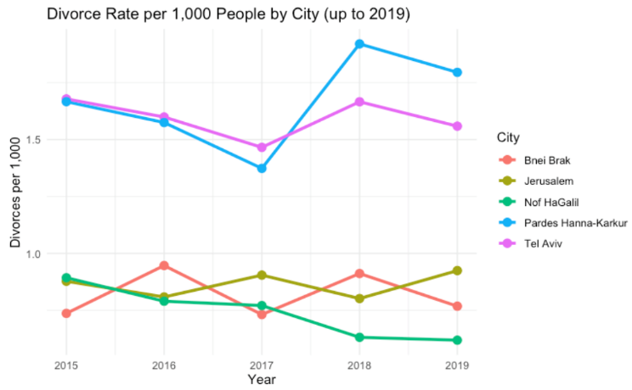

To evaluate whether cultural patterns observed in individual cities hold at a national scale, we used voting behavior as a proxy for a city’s dominant cultural identity. We examined multiple voting categories—votes_total, votes_haredi, votes_arab, votes_yemin, votes_merkaz, votes_small, and votes_other—to identify patterns associated with divorce rates. Among all these, the most distinct differences emerged in cities with high support for ultra-Orthodox (Haredi) parties and Arab parties.

As shown in Figure 2, the boxplots demonstrate that cities with stronger religious voting profiles consistently exhibited lower divorce rates, whereas more secular or culturally mixed cities tended to report higher divorce rates. 

These patterns are not unique to Israel. A demographic study from the U.S. found that “highly religious couples are less likely to dissolve their marriage than less religious couples” and that “living in a more religious municipality further reduces divorce risk”4. This suggests that both personal beliefs and the social context of religious communities play a role in stabilizing marriage.

To deepen our understanding of what influences divorce rates across Israeli cities, we moved beyond voting patterns and turned to demographic composition. Since our earlier analysis highlighted sharp contrasts between cities with strong ultra-Orthodox and Arab voting profiles, we hypothesized that religious and cultural identity at the population level, rather than at the ballot box, might reveal deeper patterns.

We therefore focused on 30 cities whose total population was closest to the national median, in order to avoid distortions from extreme cases. Using only two demographic variables, the proportion of Arab and Jewish residents, we applied *k*-means clustering to segment cities into three groups with similar cultural makeup.

Although the clustering was based solely on ethnic composition, the resulting clusters showed consistent differences in additional variables, including divorce rates, average age, job-seeker rates, household size, and education level, underscoring broader structural divides.

**Cluster 1 – Jewish-majority cities**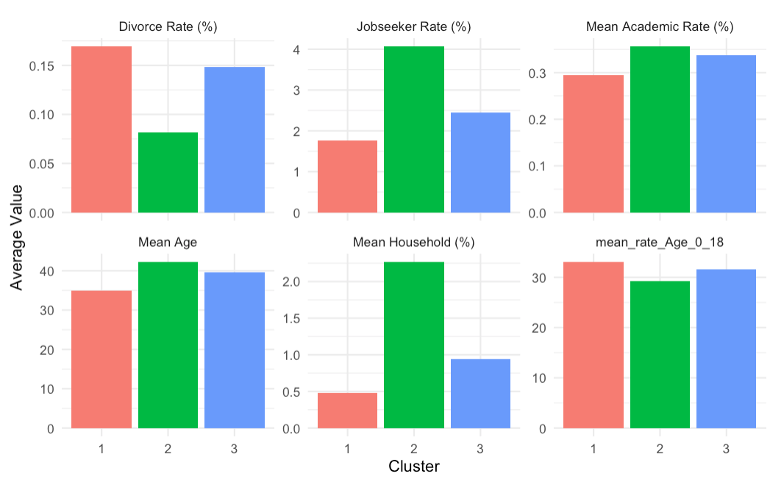

highest divorce rate (≈ 1.69%), a young average population (≈ 35), and lower educational attainment.

**Cluster 2 – Arab-majority cities**

lowest divorce rate (≈ 0.82%), these cities had the oldest populations (≈ 42.2), the highest jobseeker rate (≈ 4.07%)

**Cluster 3 – Mixed cities moderate**

divorce rate (≈ 1.48%), average age (≈ 39.7), and mid-range values for employment and education.

Taken together, these findings suggest that divorce is not determined by a single factor but by a constellation of demographic and cultural forces. While religious identity, both in terms of voting behavior and population makeup, clearly plays a role, so do broader variables like age distribution, education, and economic stability. Following the cultural clustering, we attempted to explore whether demographic factors such as age, employment, and education could independently explain divorce rates. However, these variables did not produce a consistent or meaningful segmentation of the cities. This indicates that while demographic variables contribute to divorce trends, cultural identity appears to be the more dominant and reliable factor in explaining the differences observed between cities.

**Limitations and Future Work**

While our analysis provides meaningful insights into the predictors of divorce in Israel, several limitations must be acknowledged. The data is limited to 2019, preventing examination of long-term trends or recent events. Our use of voting patterns as a proxy for cultural identity may oversimplify internal diversity within cities. Additionally, divorce rates may be underreported in certain communities, particularly Arab and ultra-Orthodox, due to cultural stigma or alternative legal practices. Finally, relying on municipal-level data restricts our ability to account for individual or household-level factors.

If we had one additional month, we would focus on collecting more detailed data about the couples themselves, recognizing that city-level generalizations may overlook more personal or nuanced factors. This could include reaching out to divorce lawyers or legal aid organizations to access anonymized data on common causes of divorce, such as emotional distance, conflict, or cultural pressures.

With three additional months, we would aim to expand the dataset across multiple years and improve the reliability of demographic indicators, particularly for underrepresented populations, in order to better capture long-term patterns and deepen the demographic analysis.

Our code repository on Github: [https://github.com/NaamaNigri01/DivorceRatesProject](https://github.com/NaamaNigri01/DivorceRatesProject%20)

Link to our data folder:

<https://drive.google.com/drive/folders/1lDg3He8peEky0_dCqKqRCU_FWzsmPqsC>

**Appendix:**

1: [**Lawdin – Divorce Rates in Israel: Trends and Cause:**](https://lawdin.co.il/%D7%90%D7%97%D7%95%D7%96%D7%99-%D7%92%D7%99%D7%A8%D7%95%D7%A9%D7%99%D7%9F-%D7%91%D7%99%D7%A9%D7%A8%D7%90%D7%9C-%D7%9E%D7%92%D7%9E%D7%95%D7%AA-%D7%92%D7%95%D7%A8%D7%9E%D7%99%D7%9D-%D7%95%D7%94%D7%A9/)

An article summarizing divorce patterns in Israel, highlighting key contributing factors such as socioeconomic conditions, religious background, and age at marriage.

2:[**OECD – Marriage and Divorce Rates (2023):**](https://www.oecd.org/content/dam/oecd/en/data/datasets/family-database/sf_3_1_marriage_and_divorce_rates.pdf)

This dataset presents cross-country statistics on marriage and divorce rates in OECD member countries, allowing for international comparison of family trends.

3: [**Ynet – Divorce Trends During COVID-19 (Dayan-Wolfner, 2020):**](https://www.ynet.co.il/parents/article/SyQ00IRFaP)

Article discussing the rise in divorce rates in Israel during the pandemic.

[**Calcalist – Divorce Trends During Wartime (Sade, 2023):**](https://www.calcalist.co.il/local_news/article/s1lqogoba)

A news report focusing on the rise in divorce cases following recent conflicts in Israel.

4:[**Demographic Research – Rligion and Divorce in the US (**](https://www.demographic-research.org/articles/volume/49/20)[**Vermeulen**](https://www.demographic-research.org/articles/articlesbyauthor/15510)[**,**](https://www.demographic-research.org/articles/volume/49/20) [**Zoutewelle-Terovan**](https://www.demographic-research.org/articles/articlesbyauthor/15511)[**,**](https://www.demographic-research.org/articles/volume/49/20) [**Kooiman**](https://www.demographic-research.org/articles/articlesbyauthor/14751)[**,**](https://www.demographic-research.org/articles/volume/49/20) [**Liefbroer**](https://www.demographic-research.org/articles/articlesbyauthor/978)[**, 2023):**](https://www.demographic-research.org/articles/volume/49/20)

A study showing that higher religiosity among individuals and communities is associated with lower divorce rates.